**GRIDCO LIMITED**

**NIT No. CGP-01/2025-26**

**For**

**Short Term Power Purchase by GRIDCO from Intra State Captive Generating Stations directly in Competitive Bidding Process for the period from April-2025 to July-2025**

GRIDCO Ltd, the designated entity for purchase of power for the State of Odisha wishes to invite tender for procurement of firm power from Intra State Captive Generators having SCADA facility and ABT compliance metering arrangement, and connectivity at 33 kV & above voltage level on short term basis during the period from 01.04.2025 to 31.07.2025 as per the details given below through competitive bidding process.

**Quantum of power to be purchased:-**

|  |  |  |  |  |
| --- | --- | --- | --- | --- |
| **Month** | **Duration** | **Quantum** | **Type** | **Delivery Point** |
| **April 2025** | **00:00 to 24:00 Hrs** | **Upto 300 MW** | **Firm** | **Interconnection Point**  **of STU (OPTCL) Captive Generating**  **Station** |
| **May 2025** | **00:00 to 24:00 Hrs** | **Upto 300 MW** |
| **June 2025** | **00:00 to 24:00 Hrs** | **Upto 300 MW** |
| **July 2025** | **00:00 to 24:00 Hrs** | **Upto 200 MW** |
| **April 2025** | **During any time Slot** | **Upto 200 MW** | **As and when required basis & available basis** |
| **May 2025** | **Upto 200 MW** |
| **June 2025** | **Upto 200 MW** |
| **July 2025** | **Upto 200 MW** |
| **April 2025 to June 2025** | **18:00 to 24:00 Hrs** | **Upto 200 MW** | **Firm** | **Interconnection Point of STU (OPTCL) Captive Generating Station** |
| **00:00 to 02:00 Hrs** |

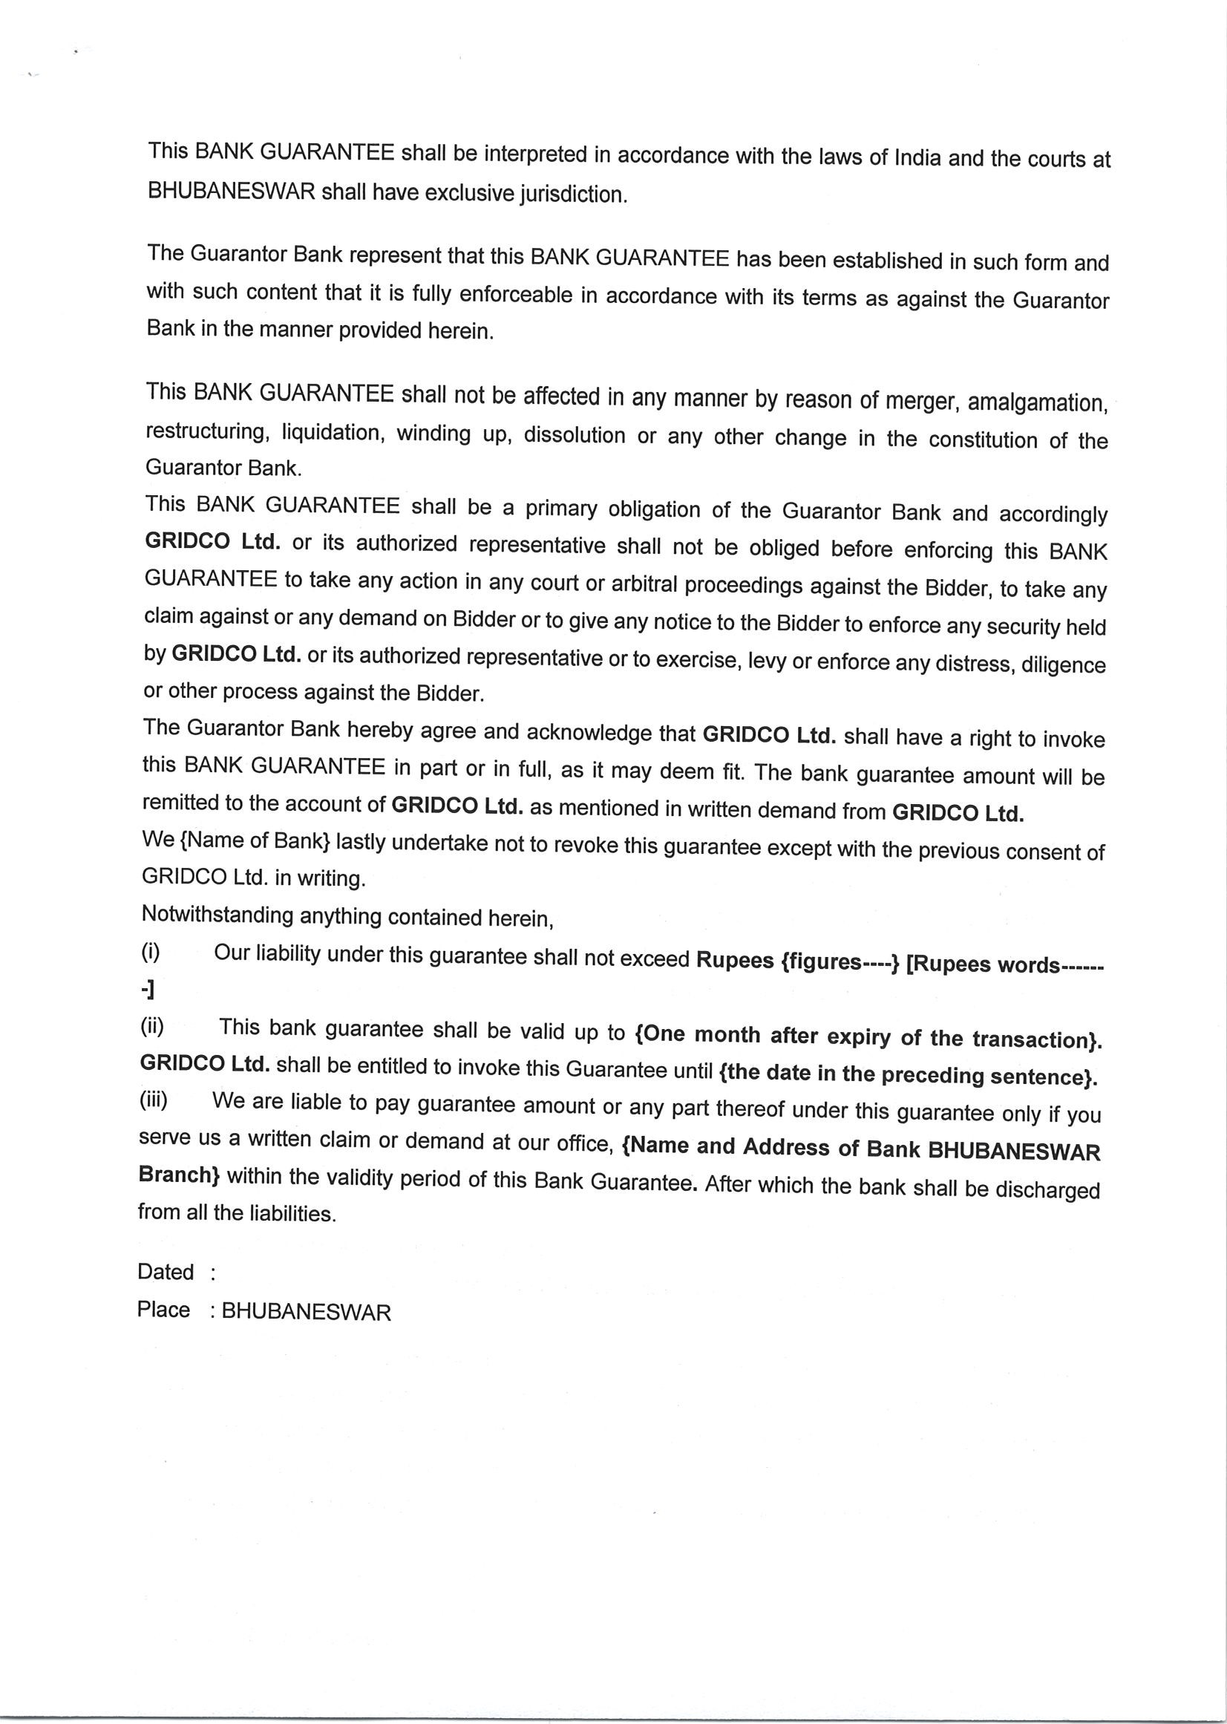

**Important Dates:**

|  |  |
| --- | --- |
| **Activity** | **Date** |
| **Publication of Tender Document** | **27.02.2025 at 17:00 hrs** |
| **Start date of Bid Submission** | **27.02.2025 at 17:00 hrs** |
| **Pre-bid meeting** | **06.03.2025 at 16:00 hrs** |
| **Last date of Submission of Bid(s)** | **12.03.2025 at 17:30hrs** |
| **Opening of Bids** | **13.03.2025 at 12:00 hrs** |
| **Commencement of Power Supply** | **01.04.2025** |
| **Place of submission of Bid(s)** | **O/o C.G.M.(PP),Gridco,Janpath, Bhubaneswar,Odisha-751022** |
| **Place of opening of bids** | **GRIDCO Conference Hall** |

**Note:-**

* All bidders are requested to go through the terms and conditions carefully before submitting the offer.
* Bidding will be done strictly in line with the provisions envisaged in the General Terms & Conditions attached as **Annexure-I** to this document.
* Price of tender document: Rs.10,000/- (Rupees Ten Thousand) only + GST @18% per bid.
* In case, last date of bid submission and date of opening happens to be a holiday, then the date of submission and opening of tenders will automatically get shifted to the next working day.
* Gridco Ltd. reserves the right to increase/decrease the quantum mentioned or cancel the bid without assigning any reason in the above table.

**CONTACT DETAILS:**

**Trading Cell,GRIDCO Limited**

**Janpath, UNIT IX, Bhubaneswar-751022**

**Mobile No-9438907588/9438908410/9438506354**

**E-mail-** [**gridco.trading.cell@gmail.com**](mailto:gridco.trading.cell@gmail.com)

**Chief General Manager (PP) I/C**

**Annexure-I**

**General Terms and Conditions**

1. **Submission of Bid**

The Bidders shall submit the bid through registered/speed post or physically before the last date and time of submission of bids. The bid shall consist of two parts, i.e. Part-I and Part-II, as under:-

**“Part-I”-Technical Bid** shall consist of:-

1. Proof of Payment of cost of Tender Documents as per Clause-2 of this document.
2. Acceptance of General Terms & Conditions of the Tender for sale of power.
3. Proof of EMD as per clause-6 of this document.

**“Part-II”-Financial Bid** shall consist of:-

1. Duly filled up format enclosed as **Annexure-A** to this document containing Bid Quantum in (MW) per unit price at the delivery point and the Interconnection point with STU.

**Note:**

Both Part-I and Part-II shall be sealed in separate envelopes and marked as “Part-I” and “Part-II” respectively. Both the envelopes shall be put together in one

Sealed envelope marked “**Intra State Power procurement by GRIDCO LIMITED**” and shall be submitted on or before **12.03.2025** at following address.

**Chief General Manager**

**Power Purchase, GRIDCO Ltd.,**

**Janpath, Bhubaneswar-751022**

**Tel (O) – 0674-2545308**

1. **Payment of price of Tender Documents**

Bidders can download the tender documents from GRIDCO’s website free of cost. However, the bidder submitting application for participation in the tender process shall require to make the payment of Rs.10,000/- (Rupees Ten Thousand) +GST @ 18% totally Rs. 11,800/- only through Demand Draft, drawn in favour of GRIDCO Limited, payable at Bhubaneswar or through transfer by RTGS/NEFT to the account, the details of which are given below:

|  |  |  |  |
| --- | --- | --- | --- |
| **Beneficiary Name** | **Account No.** | **IFSC Code** | **Bank Address** |
| GRIDCO Limited | 380801010035242 | UBIN0538086 | Union Bank of India , Bhubaneswar Main Branch, 38 Ashok Nagar,BBSR,751009 |

1. **Delivery Point**

Interconnection Point of STU (OPTCL) and Captive Generating Plant.

1. **Minimum Bid Quantum & Period:** Minimum bid quantity shall be **05 MW** on firm basis**,** the time period shall be minimum one month.
2. **Tariff:** The quoted rate shall be at Delivery Point and all charges & losses upto delivery point shall be to the account of seller.
3. **Earnest Money Deposit (EMD):**

The Bidders are required to submit EMD for the maximum capacity which they wish to offer (in single bid or sum total of multiple bids) @Rs.30,000/- per MW per month on RTC (30 days, 24 hours) basis in form of Bank Guarantee issued by any Nationalized/Scheduled Bank or Demand Draft in favour of “GRIDCO LMITED” payable at Bhubaneswar or through RTGS/NEFT transfer. The account details for RTGS/NEFT transfer are given below.

|  |  |  |  |
| --- | --- | --- | --- |
| Beneficiary Name | Account No. | IFSC Code | Bank Address |
| GRIDCO Limited | 380801010035242 | UBIN0538086 | Union Bank of India , Bhubaneswar Main Branch, 38 Ashok Nagar,BBSR,751009 |

The format of the Bank Guarantee for EMD is enclosed as **Annexure-B.**

**Note:** Earnest money, already deposited with GRIDCO by firms against any other purpose will not be considered as earnest money for the present tender under any circumstances. The EMD should reach to the Office of **Chief General Manager, Power Procurement, GRIDCO Ltd, Janpath, Bhubaneswar-751022** on or before above mentioned due date and time. (EMD can be deposited in the form of Bank Guarantee).

1. **Contract Performance Guarantee (CPG)**
2. The successful bidder shall be required to furnish CPG within 07 days from the date of selection of successful bidder for an amount calculated at Rs.2,00,000/- (Rupees Two Lakh) only per MW per month (30 days, 24 Hrs.) of contract period or part thereof.
3. The CPG shall be in the form of Bank Guarantee issued by any Nationalized /Scheduled Bank and valid for the period of contract with a claim period of 1 month after the expiry of contract or Demand Draft in favour of “GRIDCO LMITED” payable at Bhubaneswar or through RTGS transfer to the account with details given at Clause-6.
4. In the event, the CPG is not furnished within the stipulated date, the EMD submitted against the notification shall be forfeited.
5. The CPG provided by the successful bidder shall be forfeited for non-performing the contractual obligation. The CPG would be released within 30 days after successful completion of contract period.
6. **Acceptance of Tender:-**

GRIDCO Ltd. reserves the right to reject any or all bids or to accept any bid in full or part at its sole discretion without assigning any reasons whatsoever thereof. For the avoidance of doubt, it is clarified that GRIDCO Ltd. also reserves the right to alter the quantities of power/split the quantities of power as fully described in NIT, amongst more than one selected bidders for the same month. The decision of GRIDCO LTD shall be final and binding on the bidders in this respect and no further correspondence shall be entertained by GRIDCO LTD. in this regard.

1. **Disregard of Tender Conditions**

The bidder(s) should note that there shall be no deviations in respect of any terms and condition in the tender. Bid containing any deviations/ additions/ alterations/ changes in the terms and conditions of the tender shall not be acceptable. Unrelated Annexure/ Schedules of the bid or elsewhere, shall be ignored and the offer will be rejected.

1. **Modification of the Bid document**

GRIDCO LTD. reserves the right to modify terms and conditions of the Bid Documents prior to the last date of submission of the bid by issuing amendment(s) and such amendment(s) shall form part of bid documents.

1. **Bid Validity Period**

The offer shall remain valid for a period of 30 days from the date of opening of bid (“Bid Validity Period”) and the Bidders shall have no right to withdraw the offer or alter any terms and conditions during the period of validity.

1. **Contract award and conclusion**

GRIDCO Ltd. shall issue the Letter of Award (LOA) to the successful bidder(s) within 5 (five) working days from conclusion of the bid process.

1. **Scheduling**

Scheduling of power shall be as per Odisha Electricity Grid Code and shall include following:

Selling Utility shall schedule offered power in full, except in case of transmission constraints. The scheduling and dispatch of power shall be coordinated by SLDC, Odisha as per the relevant provision of OEGC and prevailing practice for scheduling of power by CGPs to GRIDCO in case the source of supply is a CGP..

1. **SLDC Operating Charges**

All SLDC charges such as SLDC application fees, (if applicable), Operation charges etc shall be borne by the seller.

1. **Billing Cycle**

The seller shall raise bills on monthly basis.

1. **Billing Procedure**

The seller shall raise the monthly bill after duly taking into account the actual injection based on the meter data certified by Energy Billing Centre (EBC), GRIDCO, implemented schedule by SLDC, Odisha and consideration of Deviation Settlement Mechanism (DSM) as mentioned at Clause-17 of this document on 15 minutes time block basis.

1. **Deviation Settlement Mechanism (DSM)**

Deviation Settlement Mechanism (DSM) Regulations, 2024 of CERC as amended from time to time or OERC DSM Regulations to be implanted within the contract period shall be applicable mutatis mutandis.

1. **Due Date**

Due date shall be the seventh day from the date of receipt of the bill by GRIDCO through e-mail ID **(**[**gridco.trading.cell@gmail.com**](mailto:gridco.trading.cell@gmail.com)and [**sgm.pp@gridco.co.in**](mailto:sgm.pp@gridco.co.in)**)** or original hard copy by O/O CGM (PP), GRIDCO**.** If due date of payment falls on GRIDCO’s holiday then the next working day shall be the due date for payment.

1. **Rebate**

The seller shall allow 2 (two)% rebate on the energy bill if the payment is made by GRIDCO on or before the due date and 1(one)% rebate if the payment is made after due date but on or before 30th day from the date of receipt of the bill.

1. **Delayed Payment Surcharge (DPS)**

A DPS @ 1.25% shall be levied by the seller on outstanding energy bill amount beyond 60 days from the date of receipt of the bill.

1. **Payment by GRIDCO**

**GRIDCO** shall endeavour to make all the energy bill payment arising out of this transaction through RTGS/NEFT to the designated account of the seller. Any payables/receivables arising out of this transaction shall not be linked to any already existing payables/receivables arising out of other transaction with the seller.

1. **Bid submission and evaluation**

To ensure competitiveness, the minimum number of Bidders should be at least two for each requisition. If the number of Bidders responding to the tender is less than two, then GRIDCO reserves the right to still continue or reject the selection process.

The Procurer shall constitute a Tender Committee for evaluation of the Bids. The Bidder with the lowest value shall be declared as the Successful Bidder for the quantum of power (in MW) offered by such Bidder in its Financial Bid. For the remaining Financial Bids of Qualified Bidders received, the procedure specified below shall apply.

The selection process of the Successful Bidder as mentioned above shall be repeated for all the remaining Financial Bids of Qualified Bidders until the entire Requisitioned Capacity is met or until the time when the balance of the Requisitioned Capacity is less than the Minimum Bid Capacity.

Provided that at any step in the process mentioned above, in case the Requisitioned Capacity has not been achieved and the Offered Capacity of the Bidder with the lowest tariff amongst the remaining Financial Bids is larger than the balance Requisitioned Capacity, the Bidder shall be asked to provide the balance Requisitioned Capacity at his quoted tariff towards meeting the Requisitioned Capacity.

1. **Governing Law**

All matters arising out of or in conjunction with the Bid Documents and / or the bidding process shall be governed by and construed in accordance with Indian Law and the courts of Bhubaneswar shall have exclusive jurisdiction.

1. **Taxes and Duties**

All taxes and duties etc. are applicable.

1. **Arbitration**

Where any dispute arises claiming any change in or regarding determination of the tariff or any tariff related matters, or which partly or wholly could result in change in tariff, such dispute shall be adjudicated by the Appropriate Commission. All other disputes shall be resolved by arbitration under the Indian Arbitration and Conciliation Act, 1996.

1. **Force Majeure**

The parties shall ensure due compliance with terms of Letter of Acceptance (LOA). However, no party shall be liable for any claims for any loss or damage whatsoever arising out of failure to carry out the terms of the LOA to the extent that such a failure is due to rebellion, mutiny, civil, commotion, riot, strike, lock out, natural calamity, Act of God and technical constraints / transmission constraints imposed by SLDC beyond the control of the parties. But any party claiming the benefit of this clause shall fully satisfy the other party within 24 hrs of such event and the Supply/drawl of power shall be resumed immediately by the parties concerned after such eventuality has come to an end or ceased to exist.

**Annexure-A**

**(To be filled by on official letter head of bidder)**

To

………………………..

……………………….

Fax no

E-mail

1. We are submitting our Price bid as under:-

|  |  |  |  |  |
| --- | --- | --- | --- | --- |
| **Month** | **Duration** | **Quantum** | **Type** | **Delivery Point** |
| **April 2025** |  | **300 MW** | **Firm** | **Interconnection Point**  **of STU (OPTCL) Captive Generating Station** |
| **May 2025** |  | **300 MW** |
| **June2025** |  | **300 MW** |
| **July2025** |  | **200 MW** |
| **April2025** |  | **200 MW** | **As and when required basis & available basis** |
| **May2025** | **200 MW** |
| **June2025** | **200 MW** |
| **July2025** | **200 MW** |
| **April 2025 to June 2025** | **18:00 to 24:00 Hrs** | **Upto 200 MW** | **Firm** | **Interconnection Point of STU (OPTCL) Captive Generating Station** |

Signature

Name:…………………………………

Designation:…………………………

Mobile No…………………………….

E-mail ID……………………………..

**Annexure – B**

**FORMAT OF THE BANK GUARANTEE FOR EMD/ CPG**

(To be on Non-judicial stamp paper of appropriate value as per Stamp Act relevant to place of execution.)

In consideration of (Insert name of the Bidder) submitting the Bid *inter alia* for power purchase period during the period {Insert Period}, in response to Tender (Ref no------------) issued by **GRIDCO Ltd.** and {Insert Name of the bidder} (Hereinafter called bidder) being a bidder is required to deposit EMD/ CPG as per terms of Tender, having agreed for submission of an irrevocable bank guarantee for **Rupees Figures------- [Rupees words----- Only],** towards security / guarantee for compliance of his obligations in accordance with the terms and conditions of the Tender.

**{Name of Bank} (**“Guarantor Bank”)

**Address:- BHUBANESWAR Branch**

**BANK GUARANTEE NO: { }**

**DATE: {Date of creation}**

**Amount: { }**

We {**Name & Address of Bank** (here in after referred to as “Guarantor Bank”) hereby agree unequivocally, irrevocably and unconditionally to pay **GRIDCO Ltd.** an amount not exceeding **Rupees {figures--- }/- [Rupees { words------}**on demand by the GRIDCO Ltd.

The Guarantor Bank do hereby undertake to pay the amounts due and payable under this guarantee without any demure, merely on a demand from **GRIDCO Ltd.** or any representative authorized by it. Any such demand made on the bank shall be conclusive as regards the amount due and payable by the bank under this guarantee However, our liability under this guarantee shall be restricted to an amount not exceeding **Rupees {figures --- } - [Rupees {words ----- }**

The Guarantor Bank do hereby expressly agree that it shall not require any proof in addition to the written demand from **GRIDCO Ltd.** or its authorized representative, made in any format, raised at the above mentioned address of the Guarantor Bank, in order to make the said payment to **GRIDCO Ltd.** or its authorized representative.

We, the said bank further undertake to pay to **GRIDCO Ltd.** any money so demanded notwithstanding any disputes raised by the bidder in any suit or proceeding pending before any court or Tribunal relating thereto, our liability under this present being absolute and unequivocal.

The Guarantor Bank further agree that the guarantee herein contained shall remain in full force and effect until **{One month after expiry of the transaction}.GRIDCO Ltd.** shall be entitled to invoke this Guarantee until **{the date in the preceding sentence}**.

The Guarantor Bank further agree that **GRIDCO Ltd.** shall have the fullest liberty without our consent and without affecting in any manner our obligations hereunder to vary any of the terms and conditions of the said Tender. We shall not be relieved from our liability by reason of any such variation.

This BANK GUARANTEE shall be interpreted in accordance with the laws of India and the courts at BHUBANESWAR shall have exclusive jurisdiction.

The Guarantor Bank represent that this BANK GUARANTEE has been established in such form and with such content that it is fully enforceable in accordance with its terms as against the Guarantor Bank in the manner provided herein.

This BANK GUARANTEE shall not be affected in any manner by reason of merger, amalgamation, restructuring, liquidation, winding up, dissolution or any other change in the constitution of the Guarantor Bank.

This BANK GUARANTEE shall be a primary obligation of the Guarantor Bank and accordingly **GRIDCO Ltd.** or its authorized representative shall not be obliged before enforcing this BANK GUARANTEE to take any action in any court or arbitral proceedings against the Bidder, to take any claim against or any demand on Bidder or to give any notice to the Bidder to enforce any security held by **GRIDCO Ltd.** or its authorized representative or to exercise, levy or enforce any distress, diligence or other process against the Bidder.

The Guarantor Bank hereby agree and acknowledge that **GRIDCO Ltd.** shall have a right to invoke this BANK GUARANTEE in part or in full, as it may deem fit. The bank guarantee amount will be remitted to the account of **GRIDCO Ltd.** as mentioned in written demand from **GRIDCO Ltd.**

We {Name of Bank} lastly undertake not to revoke this guarantee except with the previous consent of GRIDCO Ltd. in writing.

Notwithstanding anything contained herein,

(i) Our liability under this guarantee shall not exceed **Rupees {figures----} [Rupees words-------]**

(ii) This bank guarantee shall be valid up to **{One month after expiry of the transaction}, GRIDCO Ltd.** shall be entitled to invoke this Guarantee until **{the date in the preceding sentence}.**

(iii) We are liable to pay guarantee amount or any part thereof under this guarantee only if you serve us a written claim or demand at our office, **{Name and Address of Bank BHUBANESWAR Branch}** within the validity period of this Bank Guarantee**.** After which the bank shall be discharged from all the liabilities.

Dated :

Place : BHUBANESWAR